**Development of Standard Operating Procedures (SOPs) for Omics Analyses of Microbial Biofilms on Reverse Osmosis (RO) Membranes**

The integrity of analytes is crucial for any type of analytical procedure, including omics approaches. Often, the locations of sample collection and the laboratory where omics analytical processes are performed are distant. Then, samples have to be collected, handled, packaged, and possibly stored prior to shipping to the analytical laboratory. During this process, the integrity of the biological material must be maintained, and validated protocols are needed.

A crucial step for downstream omics analyses is the development of Standard Operating Procedures (SOPs) for the entire process starting with biofilm sample collection to arrival in the laboratory where omics analyses will be performed. These SOPs are generally analyte-specific although a validated SOP for a labile biomarker can probably be applied biomarkers with equal or greater stability. For omics analyses, the key analytes are DNA (shotgun metagenomics, amplicon sequencing), RNA (shotgun metatranscriptomics), protein (global and targeted proteomics), and metabolites (global and targeted metabolomics). **Figure 1** illustrates the general process from sample collection to omics data acquisition, data analysis, and omics data.



For meaningful and unbiased omics analyses, DNA, RNA, protein, metabolite integrity cannot be compromised during sample collection, handling, shipping, storage, and processing. The analytes cannot be altered (e.g., transformed or degraded) during all steps of sample manipulation. Protocols for processing DNA, RNA, and protein extracts have already been established and validated SOPs are available {Vaught, 2011 #1;Knight, 2018 #5; https://www.pdfdrive.com/forensic-biology-dna-sop-manual-e23481747.html}. Protocols for the analysis of metabolomes from defined samples are available, and efforts are underway to develop SOPs for environmental metabolomics.

To date, SOPs for sampling RO membranes under real world conditions (e.g., at a desalination plant) are lacking. Step-by-step protocols for recovering biofilm material from RO membranes from different RO modules without compromising the target analyte(s) are needed to develop SOPs.

A major goal of this effort is to establish step-by-step protocols for the recovery, on site processing, and shipping of RO membrane biofilm samples to analytical laboratories without compromising biomarker integrity. Since the biofilm metabolome is most labile and most prone to change due to transformation and degradation {Rabinowitz, 2007 #9}, the efforts will focus on step-by-step procedures that ensure the integrity of the metabolome. The assumption is that protocols that do not alter the metabolome, will also satisfy the requirements for the other omics analyses. If desired, the SOPs can then be adjusted to meet the specific needs of other omics analytes that demand less stringent protocols. In other words, the measures taken to ensure the integrity of the metabolome will also protect the proteome, transcriptome and metagenome.

Metabolomics provides a snapshot of metabolism at a specific time and therefore typical metabolomics sampling protocols include a fast filtration step followed by immediate quenching of the sample using a mixture of cold organic solvents. Since this method is not applicable to RO membranes, alternate methods, specifically cryo-freezing, will be used to quench the metabolic activity and preserve metabolites. Methods similar to these have successfully been used in other environmental studies {Bird, 2019 #10;Clemmons, 2019 #13;Dearth, 2018 #11;Mueller, 2020 #12}.

**Ice, dry ice and liquid nitrogen**

Source of information: Recommendations on the on the transport of dangerous goods, Model Regulations Volume II, Sixteenth revised edition, United Nations 2009; <https://unece.org/fileadmin/DAM/trans/danger/publi/unrec/rev16/English/Volume2.pdf>

When dry ice or liquid nitrogen is used, all applicable requirements of these Regulations shall be met. When used, ice or dry ice shall be placed outside the secondary packagings or in the outer packaging or an overpack. Interior supports shall be provided to secure the secondary packagings in the original position after the ice or dry ice has dissipated. If ice is used, the outside packaging or overpack shall be leakproof. If carbon dioxide, solid (dry ice) is used, the packaging shall be designed and constructed to permit the release of carbon dioxide gas to prevent a build-up of pressure that could rupture the packagings and the package (the outer packaging or the overpack) shall be marked “Carbon dioxide, solid” or “Dry ice”.

The primary receptacle and the secondary packaging shall maintain their integrity at the temperature of the refrigerant used as well as the temperatures and the pressures which could result if refrigeration were lost.

**Dry ice**

Source of information: <https://www.faa.gov/hazmat/packsafe/>

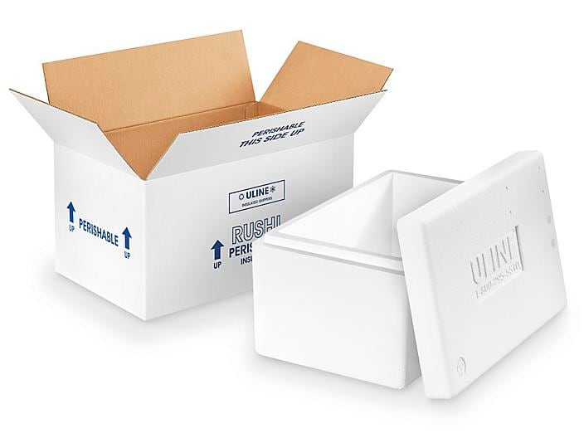

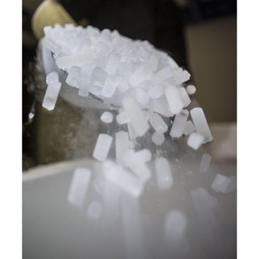

Carbon dioxide, solid, 2.5 kg (5.5 lbs) or less, when used to pack perishables

Quantity limit: 2.5 kg (5.5 lbs) per package and per passenger.

Airline approval is required.

Packages must NOT be air tight and must allow the release of carbon dioxide gas.

When in checked baggage, the package must be marked "Dry ice" or "Carbon dioxide, solid" and marked with the net quantity of dry ice, or an indication that it is 2.5 kg (5.5 lbs) or less.

See the regulation: [49 CFR 175.10(a)(10)](http://www.ecfr.gov/cgi-bin/retrieveECFR?gp=1&SID=bba5ad06518b529c94e1d67a3270196b&ty=HTML&h=L&r=SECTION&n=49y2.1.1.3.12.1.25.5)

Tip: Additional non-hazardous ice packs (blue ice, gel packs, etc.) can be used to supplement the dry ice. However, for carry-on baggage, if the product contains any liquid or gel in excess of 100 mL (3.4 oz) per container, the TSA security rules require that the product be in the frozen state (i.e., solid) when the passenger goes through security screening.

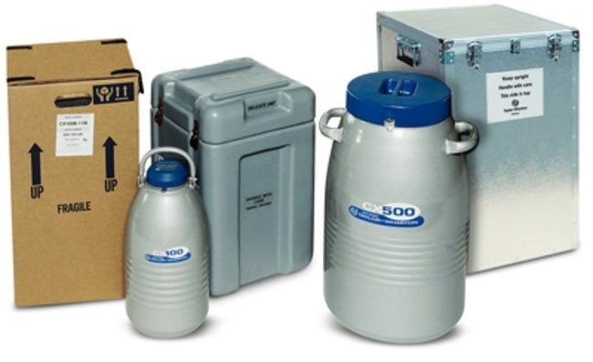**Dry shipper**

Source of information: <https://www.faa.gov/hazmat/packsafe/>

[www.ehs.washington.edu](http://www.ehs.washington.edu)

A dry shipper is an insulated cryogenic flask/container that contains refrigerated liquid nitrogen absorbed into a porous lining. It is used to transport specimens.

Quantity limits: N/A

The liquid nitrogen must be completely absorbed into the container lining; there must be no free liquid.

Container must not allow the buildup of pressure.

Liquid nitrogen must not escape from the package regardless of the package orientation.

See the regulation: [49 CFR 175.10(a)(24)](http://www.ecfr.gov/cgi-bin/retrieveECFR?gp=1&SID=bba5ad06518b529c94e1d67a3270196b&ty=HTML&h=L&r=SECTION&n=49y2.1.1.3.12.1.25.5)

(24) Insulated packagings containing refrigerated liquid nitrogen when carried in checked or carry-on baggage in accordance with the ICAO Technical Instructions (IBR, see §171.7 of this subchapter), Packing Instruction 202, the packaging specifications in part 6, chapter 5, and special provision A152.

Tip: It is normal to sometimes see vapor coming from these containers as they must allow the escape of gaseous nitrogen.

Liquid nitrogen is a regulated by the United States Department of Transportation (USDOT) and cannot be shipped by aircraft.

Properly filled dry shippers are not subject to regulation as a Hazardous Material by the USDOT. Improperly filled dry shippers present a risk of liquid nitrogen leakage and are subject to regulation by the USDOT should spillage occur.

Correctly prepared dry shippers do not contain free liquid nitrogen. The dry shippers are capable of maintaining the materials in them at liquid nitrogen temperatures of -195°C for at least 24 hours without the risk of spilling liquid nitrogen.

While liquid nitrogen is a Hazardous Material regulated by the USDOT, a properly prepared dry shipper is not. This allows for more flexibility and less cost when shipping non-hazardous frozen materials.

**Loading dry shippers with liquid nitrogen**

Follow the manufacturer’s instructions for filling. Some general practices when filling the dry shipper are:

1. Wear insulated gloves made for handling liquid nitrogen and a face shield.
2. Add the liquid nitrogen slowly since a significant volume of nitrogen gas will form as the cold liquid contacts warm surfaces.
3. When the liquid level reaches the neck of the dry shipper, stop filling. Replace the cap and set the dry shipper aside for the period specified by the manufacturer to allow the liquid nitrogen to saturate the absorbent.
4. Repeat steps 1-3 until the liquid level no longer drops on standing. This may require as many as 15 repetitions.

Some manufacturers report empty and full weights for their dry shippers. Dry shippers that will not achieve their full weight may indicate a problem with the absorbent’s ability to hold the liquid nitrogen. This may prevent maintaining liquid nitrogen temperature during shipment and may damage your samples. Contact the manufacturer to determine if the dry shipper is safe to use.

**Preparing “dry shippers” for transport**

Remove all free liquid nitrogen from the “dry shipper” before transport.

1. Wear insulated gloves and a face shield when emptying the dry shipper.
2. Empty the dry shipper by inverting it in an appropriate area.
3. Do not pour liquid nitrogen onto the floor since it could splash onto your shoes or legs and cause severe burns. It is a good idea to pour the excess liquid nitrogen back into a large liquid nitrogen dewar vessel.
4. Hold the dry shipper upside down until the liquid stops flowing.
5. Stand the dry shipper upright for the period specified by the manufacturer.
6. Repeat steps 1-4 as many times as necessary to remove any remaining liquid nitrogen.
7. Place your canes of material into the dry shipper and replace the cap.
8. Place the dry shipper into the case supplied by the manufacturer.
9. Complete and sign the “Dry Shipper” Checklist (below). Keep the Checklist until you have confirmation that the dry shipper has safely reached its destination.

Be sure that the materials you are transporting are not hazardous materials such as samples frozen in propane, ethane, halocarbon or another hazardous gas. If you are uncertain about the samples of the dry shipper, do not ship the dry shipper. Keep the samples frozen on site and contact tbd.

**Dry Shipper Checklist**

**Source of information:** www.ehs.washington.edu

Instructions:

1. For each item in the checklist, enter “T” (true), “F” (false) or “N/A” (not applicable).
2. Sign and date the completed checklist.
3. Save the checklist until the shipment has reached its destination.

|  |  |  |
| --- | --- | --- |
|  |  | **True/False** |
| 1. | I have the necessary technical knowledge and training to prepare this “dry shipper” for transport. |  |
| 2. | The “dry shipper” was fully charged with liquid nitrogen in accordance with the manufacturer’s instructions. |  |
| 3. | Free liquid nitrogen has been removed from the “dry shipper” by a minimum of two inversions. |  |
| 4. | The “dry shipper” does not contain any Hazardous Materials such as explosives, propane, ethane, halocarbon or other hazardous gases. |  |

Name (print) _________________________________

Signature ___________________________________

Container Number/Identifier ______________________

Time _________________________________

Date ___________________________________

**Chain of Custody Form**

To be added